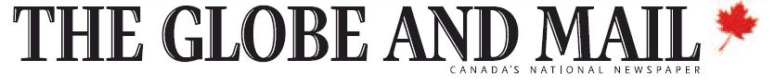

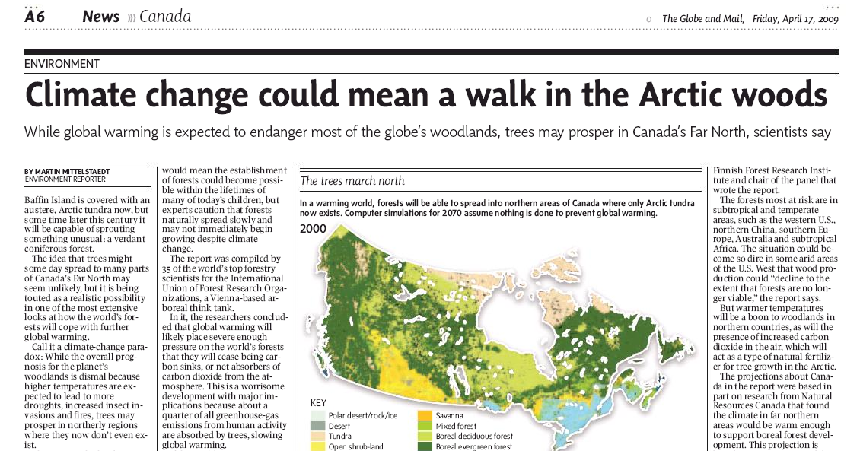
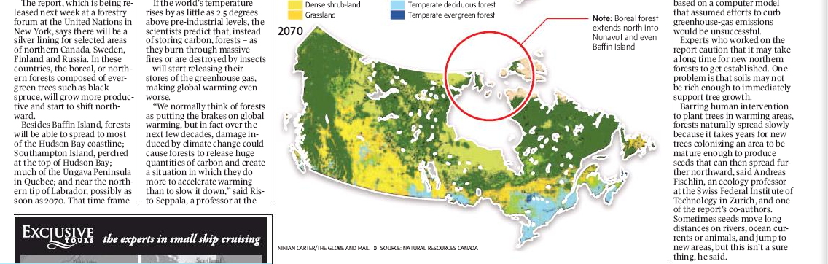

http://www.theglobeandmail.com/servlet/story/LAC.20090417.FOREST17ART2237/TPStory/Environment

