FIGs 1-3:
Phytotron experiment at Helmholtz Centre Munich: Combined CO₂/O₃ impact on mixed and monocultures of Norway spruce (Picea abies) and European beech (Fagus sylvatica); Photos: T.E.E. Grams

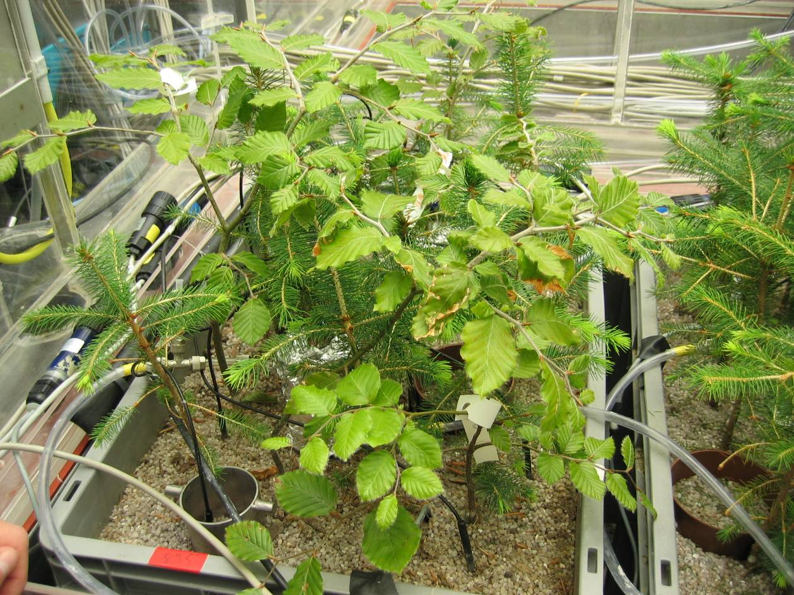
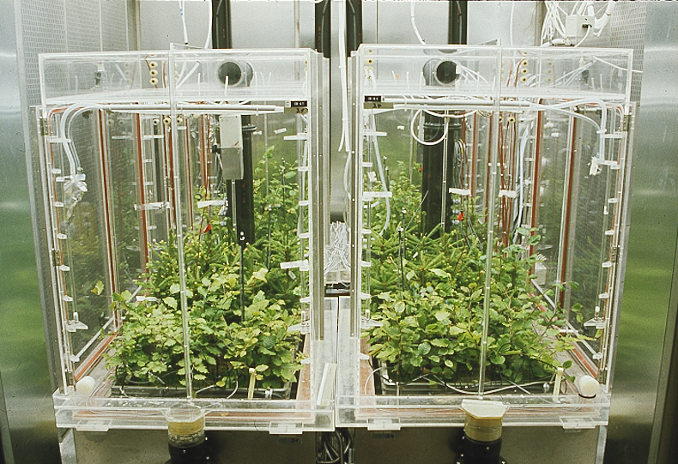
Fig. 1
Fig. 2

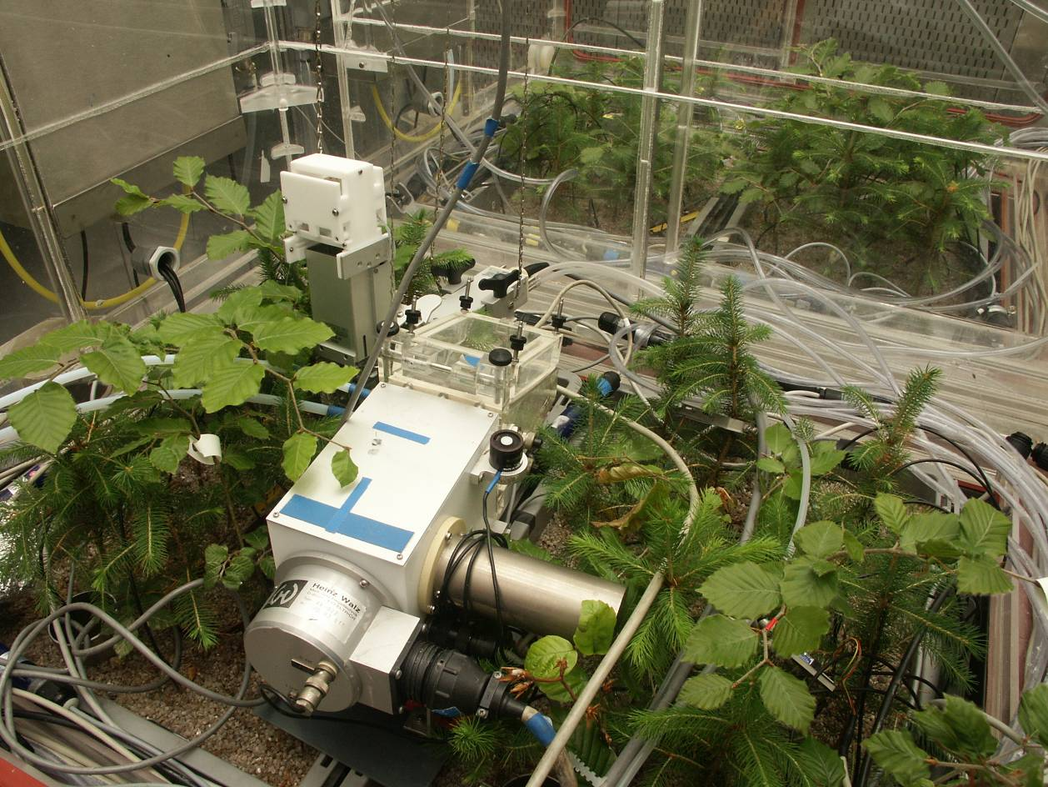
Fig. 3

