REFORESTATION CHALLENGES

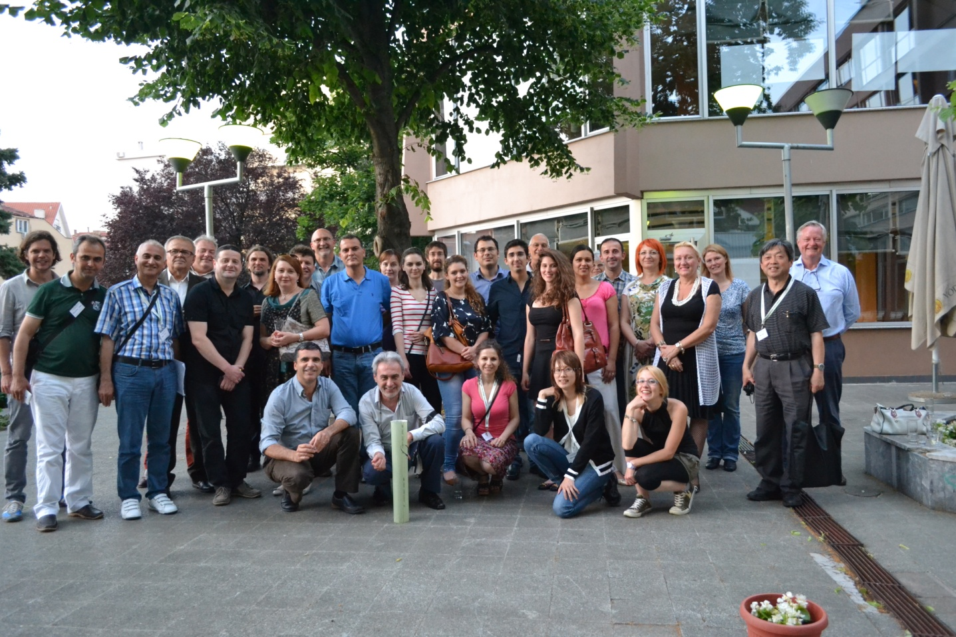
Reforestation Challenges, Belgrade 2015: Group picture. Photo by Simon Place/copyright Simon Place.
Report provided by Vladan Ivetić, Associate Professor of the Faculty of Forestry, University of Belgrade, Serbia
The conference on "Reforestation Challenges" took place on 3-6 June 2015 in Belgrade, Serbia. The Faculty of Forestry of the University of Belgrade is a member of IUFRO. The Conference was sponsored by following IUFRO Divisions and Units: 1.01.03 - Temperate Forest Regeneration, 2.00.00 - Physiology and Genetics, and 3.02.00 - Stand Establishment and Treatment.
The event was dedicated to celebrate the 95th anniversary of Faculty of Forestry – University of Belgrade. Total of 68 participants from 17 countries attended the conference.
The International Conference on Reforestation Challenges was an opportunity for scientists to gather and present results and relate experiences from research areas relevant to reforestation. Top researchers from Europe and North America have been designated as invited speakers. Conference objectives were to provide an opportunity for dynamic and ongoing cooperation between researchers, and to present results of the conference in a thematic publication covering all aspects of the reforestation process. The conference presentations filled the gaps in knowledge regarding successes and failures in reforestation practices. Overall, the Conference highlighted challenges of reforestation and provided some solutions, by contribution to interactions between researchers and practitioners. All researchers, and particularly young ones, got additional support and opportunity to exchange information and to build their research network and collaborative abilities.
Conference sessions:
- Planning and management of reforestation programs
- Stocktypes and seedlings quality
- Monitoring reforestation successes
- Planting and seedling-site interaction
- Species, intra-species and seed source selection
- Plant health in nurseries and plantations

Voluntary field trip took place after the conference. Interested participants visited Seed Centre and Nursery Požega and Research and Education Base of Faculty of Forestry on the mountain Goč.

The book of abstracts was published prior the conference. A total of 94 abstracts with 215 authors from 20 countries were accepted.
After a peer review the Conference proceedings will be published from papers presented orally or as posters at the Conference. Selected papers will be published in the Thematic proceedings until end of 2015.
Related publications /websites:
Ivetić, V., Ćirković-Mitrović T. (eds.) Book of abstracts: International conference Reforestation Challenges, 03-06 June 2015, Belgrade, Serbia. pp. 116, ISBN 978‐86‐918861‐0‐3.
Conference website: http://www.reforestationchallenges.org/

