IUFRO Meeting Report Form

Organizers of IUFRO meetings and IUFRO focal persons at IUFRO co-sponsored meetings, respectively, are kindly requested to fill in and return this form within two weeks after the meeting by email (wolfrum@iufro.org), fax (+43-1-877 01 51-50) or mail (IUFRO Headquarters, c/o BFW, Hauptstrasse 7, 1140 Vienna, Austria). This information will be posted at the relevant IUFRO web pages and may be used for IUFRO News and the IUFRO Annual Report.

(Note: Save this file under a new name and write directly into the form.)

1) IUFRO focal person/meeting organizer:

Name: Xiping Wang
Houjiang Zhang

Function in IUFRO: Coordinator, Research Group D5.01
Deputy Coordinator, Working Party D5.01.09

Email: xwang@fs.fed.us
hjzhang6@bjfu.edu.cn

2) Meeting report (max. 100 words per paragraph)

A technical workshop titled New Advances in Nondestructive Evaluation of Wood was held in Beijing on May 7-9, 2018. Co-sponsored by Beijing Forestry University, the International Union of Forest Research Organizations (IUFRO) Research Group D5.01.00―Wood and fiber quality, Working Party D5.01.09―Non-destructive evaluation of wood and wood-based materials, and the Key Laboratory of State Forestry Administration on Forestry Equipment and Automation, China, the workshop attracted over 50 individuals from various universities, research organizations, and priviate sectors in eight countries (Brazil, Canada, China, Germany, Hungary, Japan, New Zealand, and the United States). The technical presentations were focused on the most recent advances in non-destructive and precision-based technologies for evaluating wood quality of forest resources and assessing structural conditions of historic timber structures. The participants also discussed how these technologies and the knowledge obtained from them can support development of the next generation of forests and forest products, and facilitate conservation of historic wood structures around the world. A series of poster displays and equipment were exhibited.

The technical workshop was held in conjunction with the inaugural meeting of the Joint International Research Institute for Nondestructive Testing and Evaluation of Wood, a newly established research organization at Beijing Forestry University. The mission of this joint international research institute is to further strengthen international scientific research cooperation in the field of nondestructive testing and evaluation of wood and timber structures, expand relevant scientific exchanges, and promote technology transfer of advanced nondestructive evaluation techniques. Following the workshop, a meeting of the academic advisory committee was held to identify technical areas for potential research collaboration.

Key issues discussed/latest findings in the field:

- Emerging technologies for in-forest wood quality assessment
- Hardwood assessment for new products in a changing world
- Status, limit, and future of NIR technology for nondestructive evaluation of wood
- Advances in deployment of non-destructive strength and stiffness measures
- LiDAR-based estimates of forest canopy metrics
- Inspection, protection and preservation of historic timber structures

Conclusions (if possible, summarize key conclusions across presentations):

Outlook to future activities (proceedings, future meetings, other):

A technical workshop “Evaluation and Conservation of Historic Structures” is planned for September 2019, Freiberg, Germany. It will be held in conjunction with the 21st International Nondestructive Testing and Evaluation of Wood Symposium. This workshop will be sponsored by the IUFRO D5.01 and held prior to the symposium. It will include lectures on inspection techniques and case studies, followed by a tour of local, historic buildings.

Background information (meeting context):

3) Other information:

Meeting data:

Full title of the meeting: Technical Workshop “New Advances in Nondestructive Evaluation of Wood”

Date and venue: May 7-9, 2018, Xijiao Hotel, Beijing

Meeting website: n/a

Number of participants: 50

Countries represented: 8

Organization of the meeting:

All IUFRO Units involved: Research Group D5.01.00
Working Party D5.01.09

Host organization(s) and sponsor(s):
Beijing Forestry University
IUFRO
Key Laboratory of State Forestry Administration on Forestry Equipment and Automation, China

Study tour(s) to:

Communication activities (dissemination of information about the meeting; promotion of IUFRO):
Workshop Program (attached)

Related publications /websites:

4) Photos

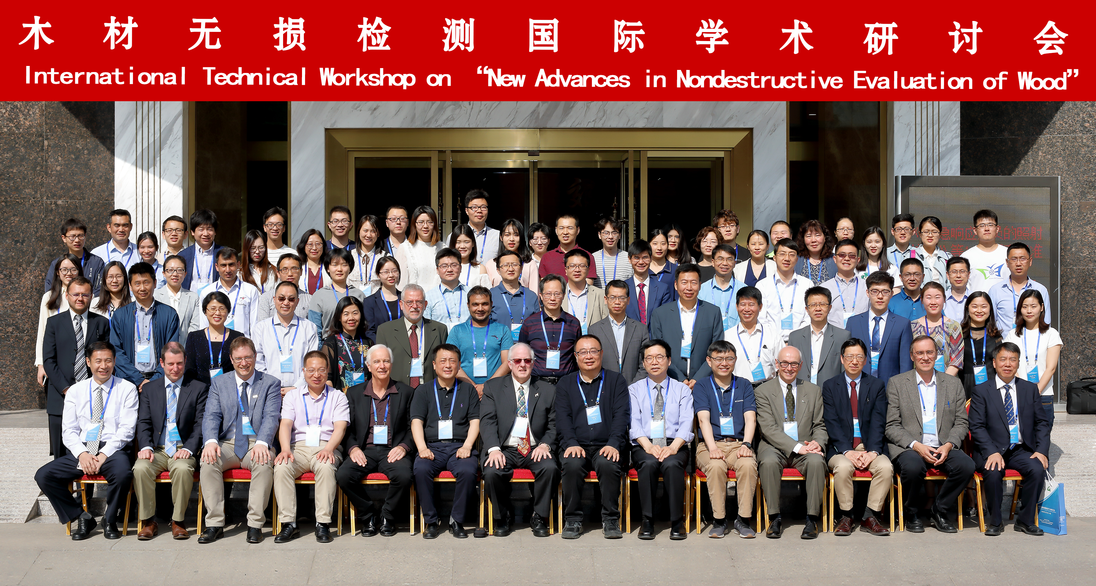

Legend: Workshop participants (Photo: Courtesy of Beijing Forestry University)

Copyright: Beijing Forestry University

5) Participants

Participants and their contact information: (to be used for the Virtual Address Book of your Unit). You can also provide the information in an Excel file.

First Name | Last Name | E-Mail | Country | Organization
John | Doe | john.doe@testmail.com | Austria | United Foresters of Austria
etc.

