Figs. 8-12:
Experimental site Kranzberg Forest (Germany): Free-Air O₃ canopy fumigation of adult Norway Spruce (Picea abies) and European beech trees (Fagus sylvatica)
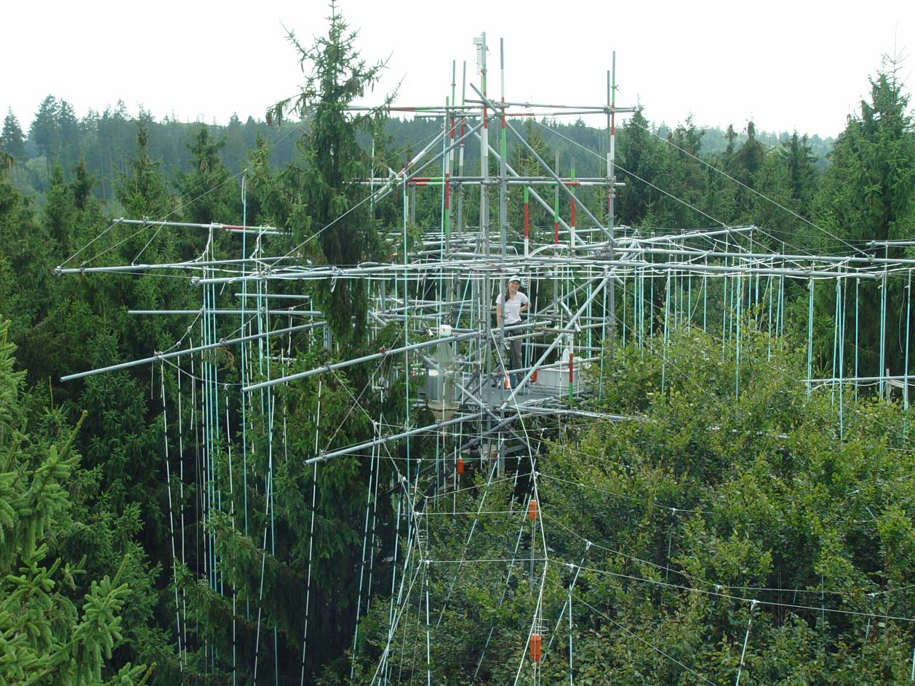
Fig. 12 /Photo: T.E.E. Grams
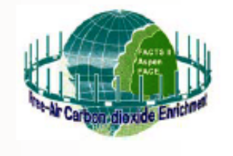
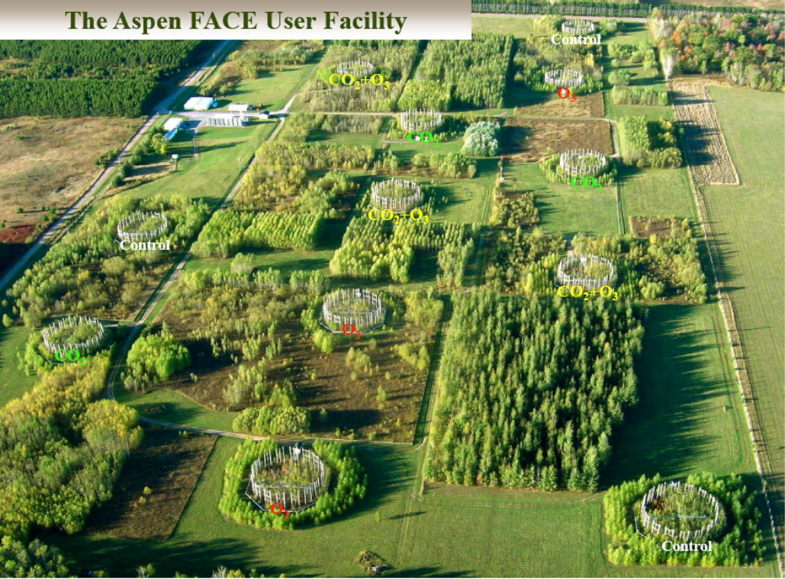

Fig. 13:
Aspen FACE experiment in Rhinelander/WI (USA):
combined CO₂/O₃ effects on tree plantations with birch, poplar and maple species; Photo: D.F. Karnosky

